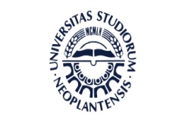

International Summer School on European Multilingualism
Faculty of Philosophy, University of Novi Sad, 7th - 14th July 2018

Faculty of Philosophy
Dr Zorana Đinđića 2,
Novi Sad 21000
Serbia
Registration form
- Language group you wish to enroll in :
- German
- French
- Italian
- Spanish

SURNAME :

First name:

Address:

Town:

Country:

E-Mail:

Study level:

Home university:

You can pay for the registration fee through a bank transfer (see the instructions for payment) or in a bank in Novi Sad:
